Lab Report: Flask for ML Model Deployment

University Mohammed VI Polytechnic
College of Computing
Professor: Fahd KALLOUBI
Course: CS3 - MLOps
Academic Year: 2025/2026
Submission Date: November 2025
MAHMOUD MAFTAH

INTRODUCTION:
This lab focuses on deploying machine learning models as web applications using Flask framework. The lab coveres Flask fundamentals including routing, template rendering with Jinja2, form handling

1. Introduction
1.1 Objectives
Master Flask web framework for ML deployment Implement Jinja2 templates for dynamic content rendering HTTP requests and form data Deploy ML models as web services Use Git and Heroku for production deployment
1.2 Environment Setup
Tools Installed:
- Git for version control
- Heroku CLI for deployment
- Flask framework (pip install flask)
- Virtual environment configuration in IDE
Note: Used VSCode instead of PyCharm as specified in lab instructions. Flask functionality remains identical across IDEs.

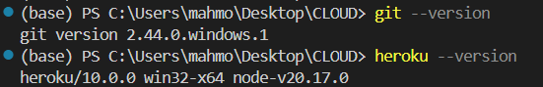

2. Flask Fundamentals
2.1 Example 1: Basic Flask Application
- Objective: Verify Flask installation with minimal application.
- Implementation: Created hello.py with single route returning "Hello World" Used @app.route('/') decorator for root endpoint Ran application on default port 5000
- Results: Successfully accessed http://127.0.0.1:5000/ Verified Flask installation and basic routing mechanism
2.2 Example 2: Template Rendering
- Objective: Learn Jinja2 template engine integration.
- Implementation: Created app.py with /result route Passed dictionary data to template Used Jinja2 syntax in result.html for dynamic table generation Utilized {% for %} loops and {{ variable }} syntax
- Key Observations: Templates must be in "templates" folder (Flask convention) Jinja2 separates presentation logic from business logic Debug mode enabled with app.run(debug=True) for auto-reload
2.3 Example 3: Form Handling
- Objective: Process user input via HTML forms.
- Implementation: Created two routes: / (GET) for form display, /result (POST) for processing Built student.html form with text inputs Captured form data with request.form Rendered results in result.html table
- Key Features: POST method for form submission request.form dictionary contains all form fields Same result.html template reused with different data

Example 1:
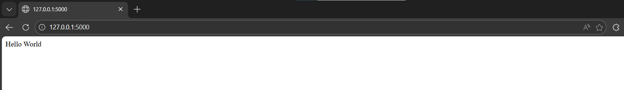
Example 2:
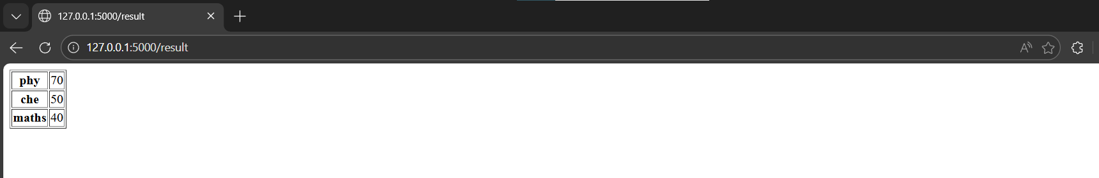

Example 3:
INITIAL FORM
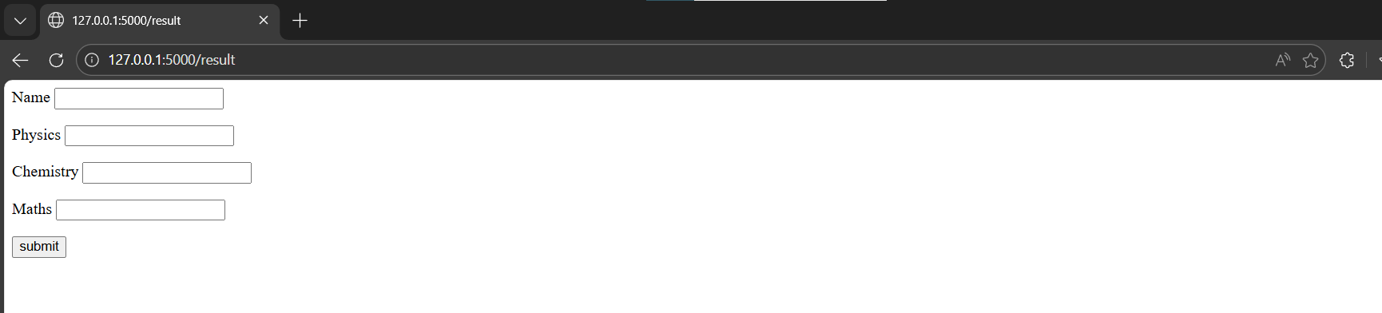
FORM FILLING
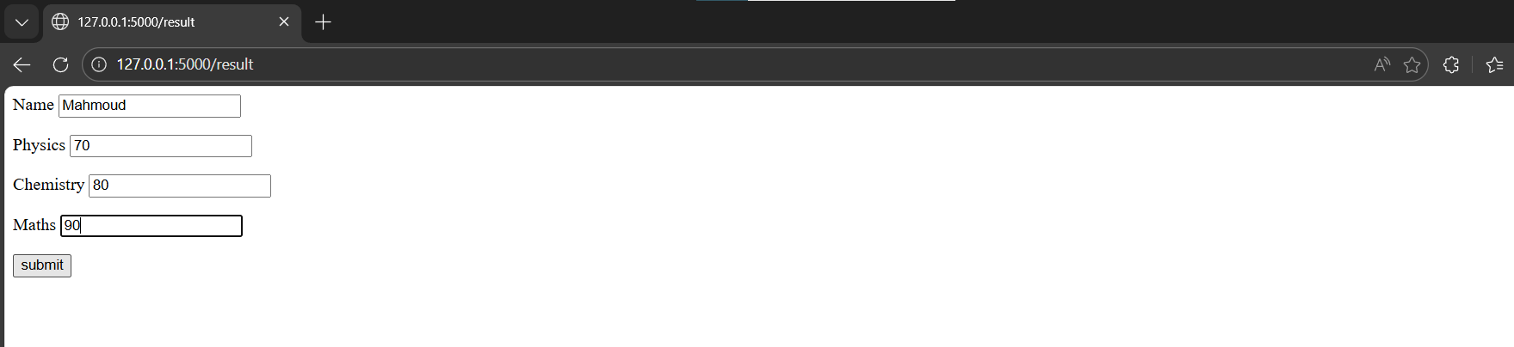
RENDERED OUTPUT
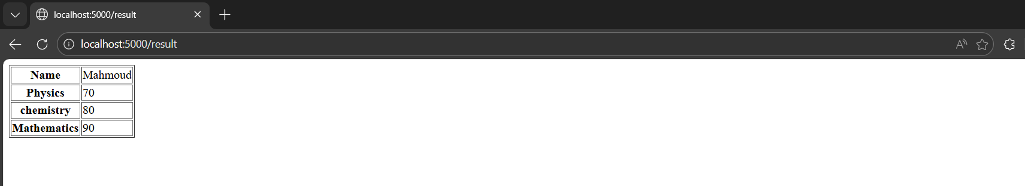

3. ML Model Deployment

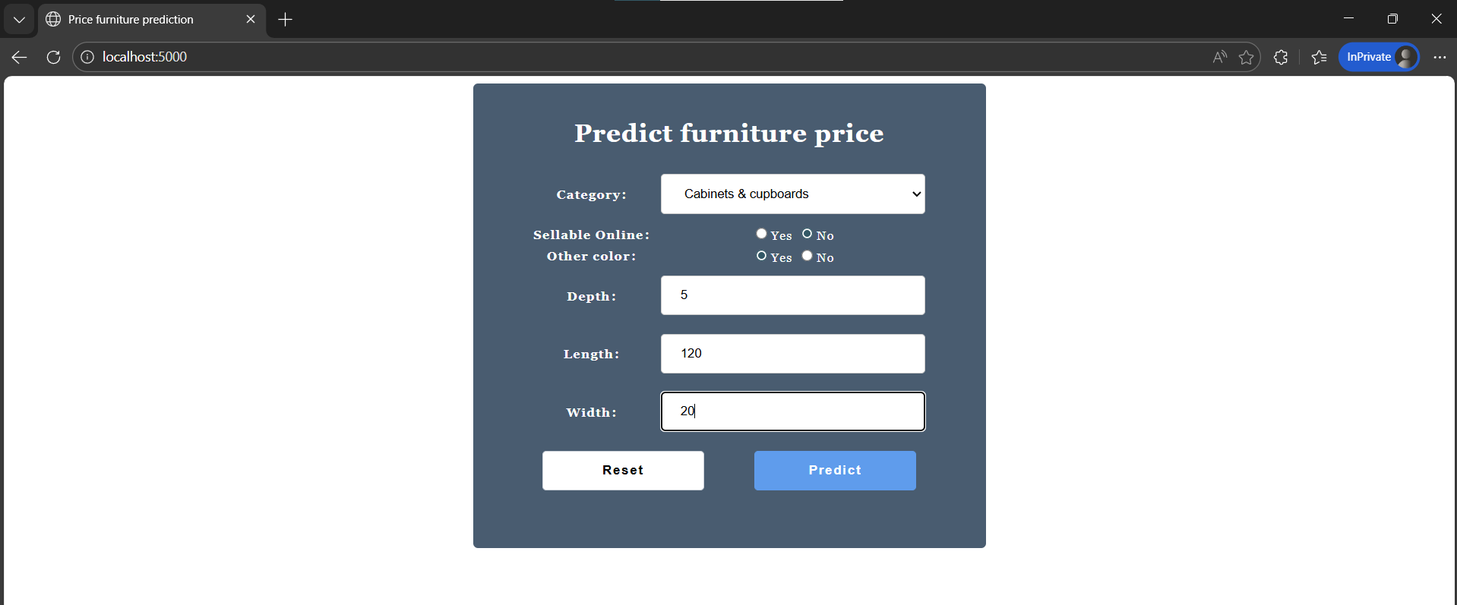

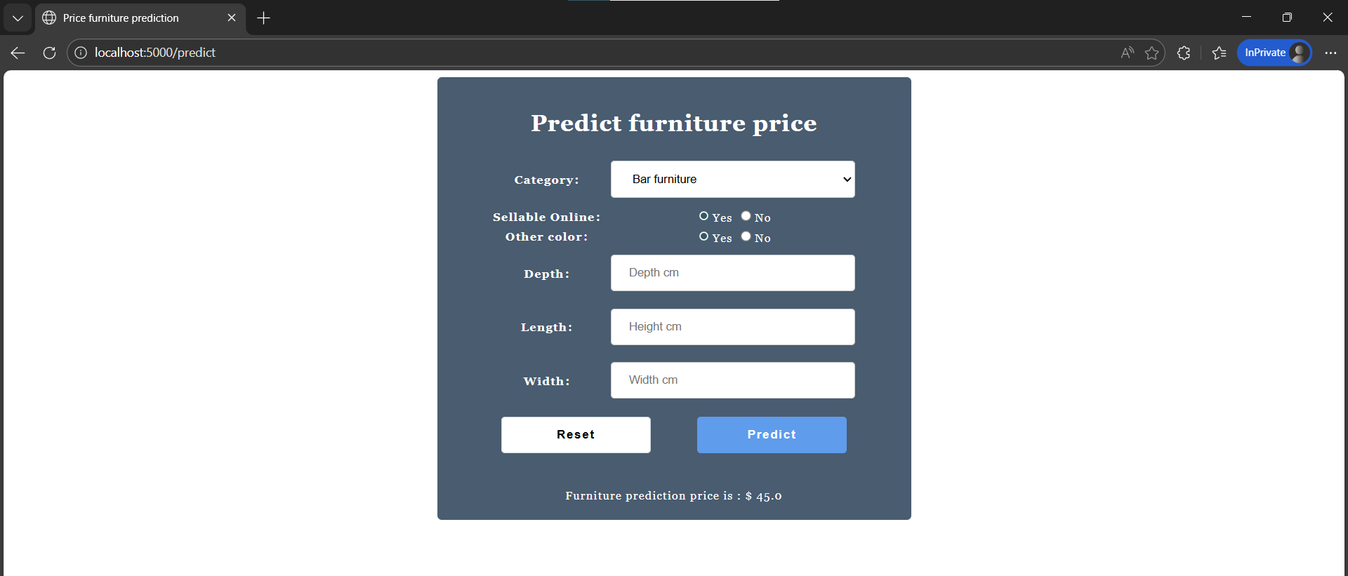

Assignment:

1. Dataset and Exploratory Data Analysis
1.1 Dataset Overview
Used the Wine dataset from sklearn containing 178 samples with 13 chemical features. The dataset has 3 wine classes with no missing values.
1.2 Data Exploration
- Analyzed feature distributions and correlations
- Visualized class balance
- Examined relationships between key features using pairplots
- Identified potential outliers using box plots

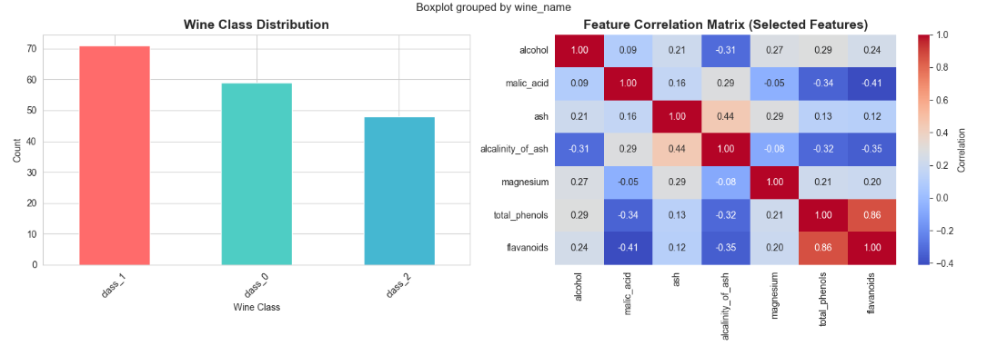
2. Data Preprocessing
2.1 Missing Values
Implemented median imputation strategy (dataset had no missing values but code is robust for future use).
2.2 Outlier Detection
Used IQR method to detect outliers in features. Handled outliers through RobustScaler during feature scaling.
2.3 Train-Test Split
Split data 80-20 with stratification to maintain class balance.
- Training: 142 samples
- Testing: 36 samples
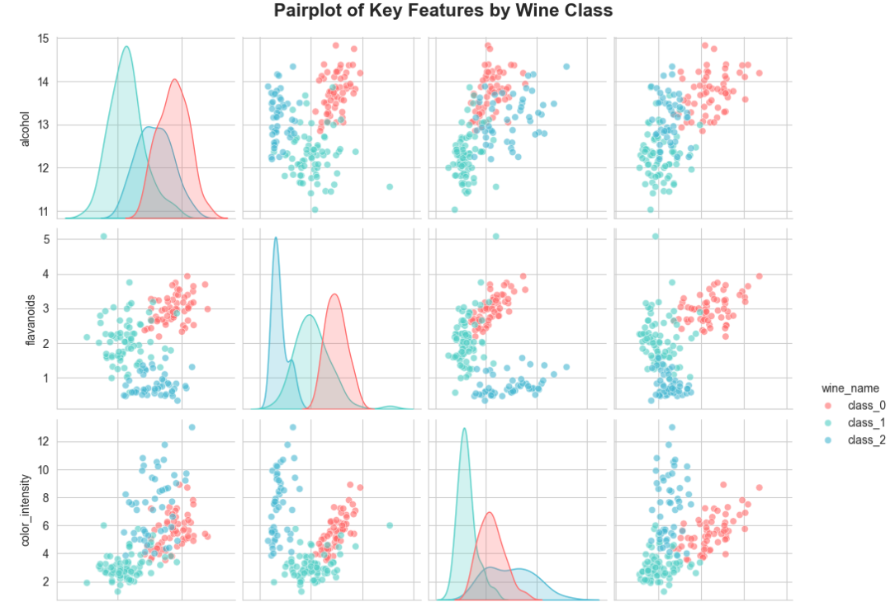
3. Feature Engineering
Created additional features to improve model performance:
3.1 Interaction Features
- alcohol × flavanoids
- alcohol × proline
- color_intensity × hue
- total_phenols × flavanoids
3.2 Ratio Features
- phenols/flavanoids ratio
- alcohol/malic_acid ratio
- ash/alkalinity ratio
3.3 Aggregate Features
- Total chemical sum
- Phenolic compounds sum
3.4 Binned Features
- Alcohol categories (3 bins)
- Proline categories (3 bins)
Result: Increased from 13 original features to 24 total features.

4. Feature Scaling
Compared three scaling methods:
- StandardScaler
- RobustScaler
- MinMaxScaler
Selected best scaler based on quick logistic regression test. RobustScaler performed best due to outlier handling.

5. Feature Selection
Applied multiple feature selection methods:
5.1 Statistical Methods
- ANOVA F-statistic (SelectKBest)
- Mutual Information scores
5.2 Tree-Based Importance
- Random Forest feature importances
5.3 Recursive Feature Elimination (RFE)
- Used with Logistic Regression as estimator
5.4 Ensemble Voting
Selected features appearing in at least 2 methods. Final selection: [X] features.
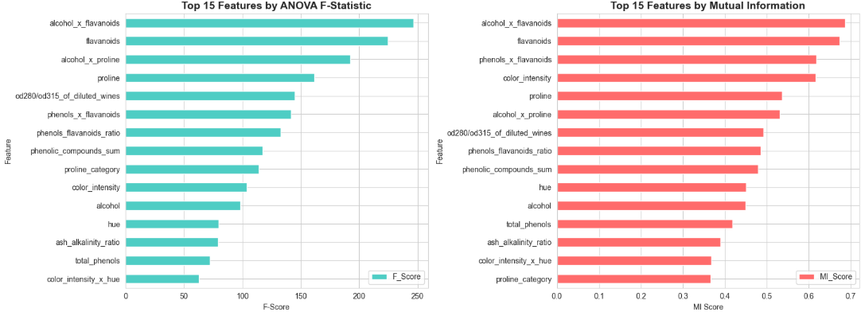

6. Dimensionality Reduction
6.1 PCA Analysis
- Applied PCA to understand variance distribution
- Found that [X] components explain 95% of variance
- Created scree plot and cumulative variance plot
Decision: Used selected features instead of PCA for better interpretability.
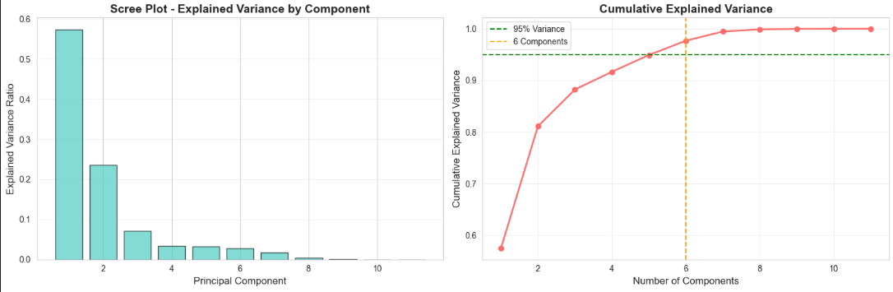

7. Model Training and Comparison
Trained and compared 11-12 models:
- Logistic Regression
- Random Forest
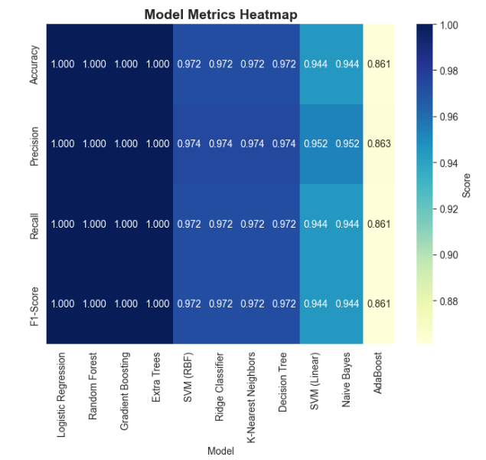
- Gradient Boosting
- Extra Trees
- AdaBoost
- SVM (RBF kernel)
- SVM (Linear kernel)
- K-Nearest Neighbors
- Naive Bayes
- Ridge Classifier
- Decision Tree
- XGBoost (if available)
Evaluation Metrics:
- Accuracy
- Precision
- Recall
- F1-Score
- ROC-AUC

Screen form the form interface:
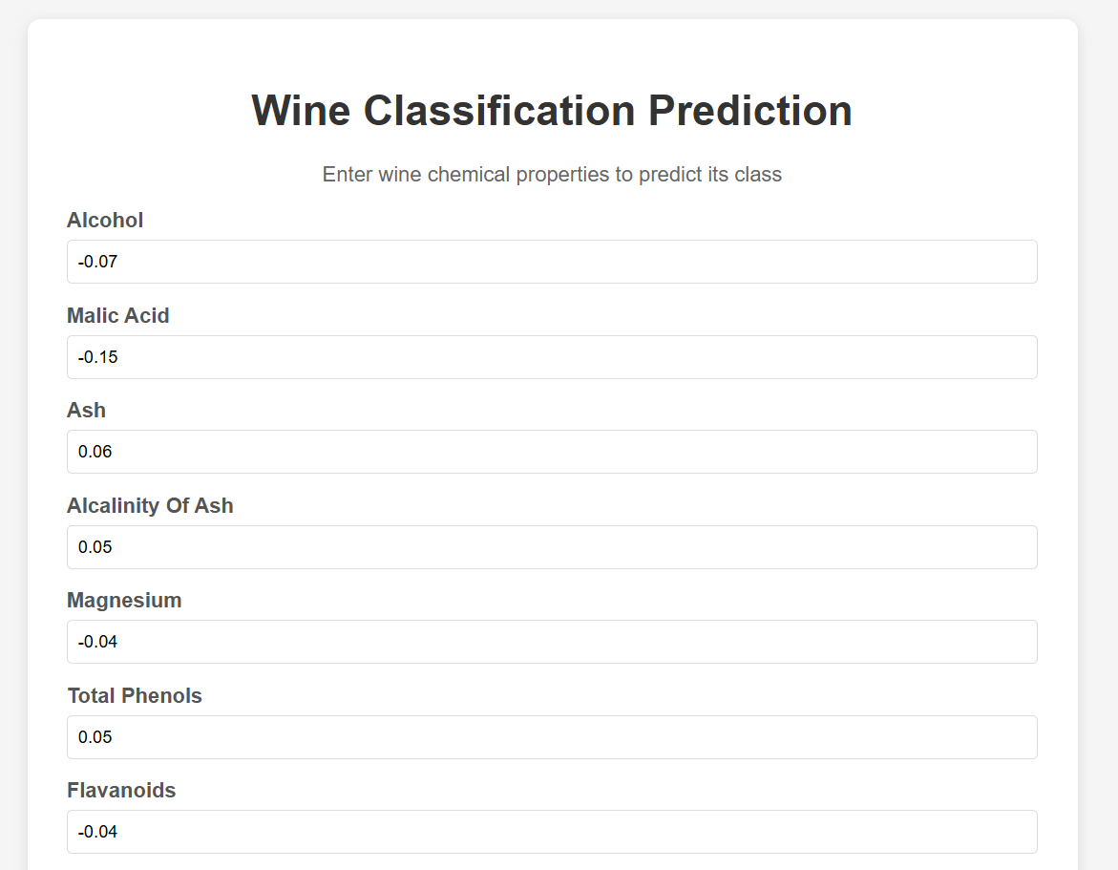

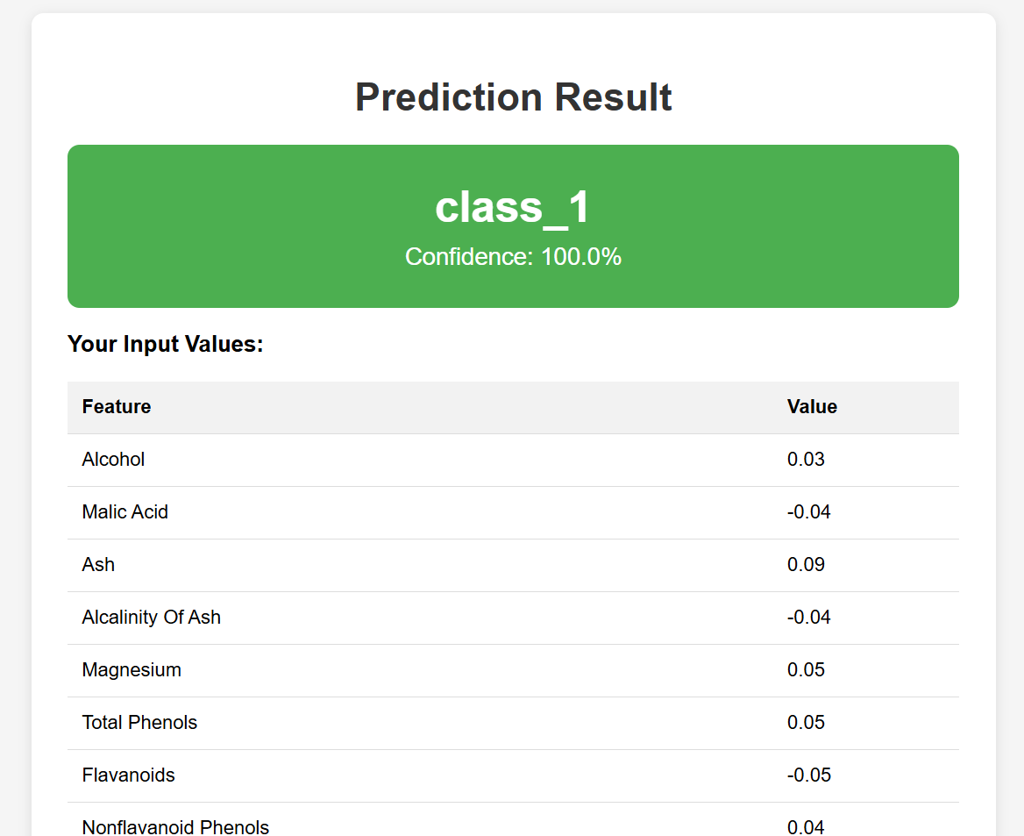
Using the results view from templates to display results of our entered values:

